|  |  |  |  |  |
| --- | --- | --- | --- | --- |
| TradeNet Mailbox ID: | aam1001 | aam1002 | aam1003 | Aam1004 |
| Declarant name: | Wong Shuh Yi | Koh Siew Fen | Ng Seok Leng | Yuliana Kosasih |

<https://tradeweb.crimsonlogic.com/tnlitd/ana/LogoutServlet>

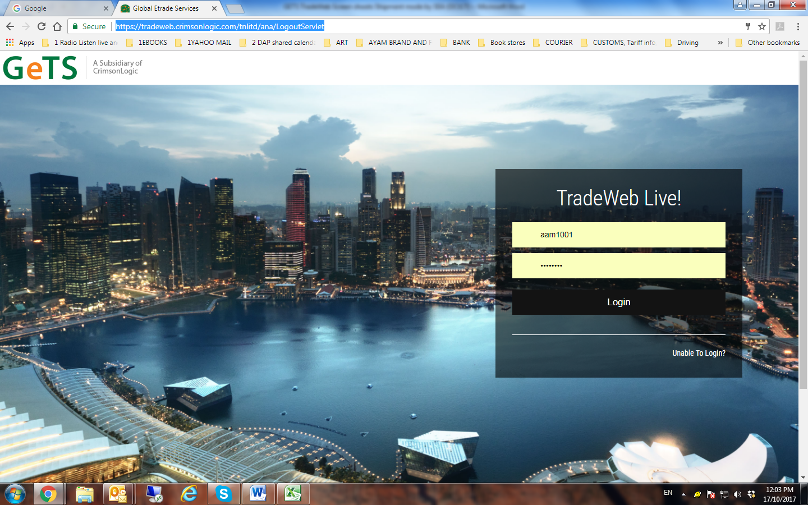

TradeWeb Live login ID = TradeNet Mailbox ID

Password = (individual mailbox ID to manage their own pw)

**CARGO IMPORT PERMIT DECLARATION – MODE : by SEA**

New declaration

In payment

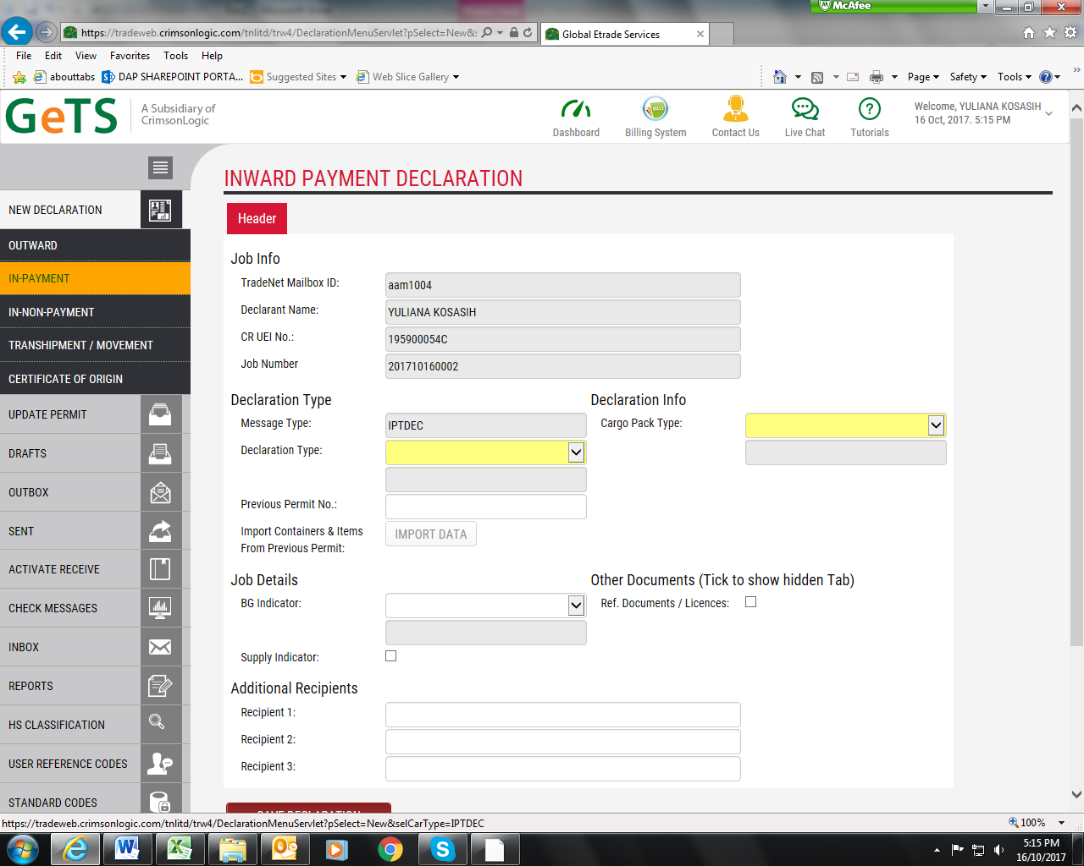

Bottom red button: Save Declaration

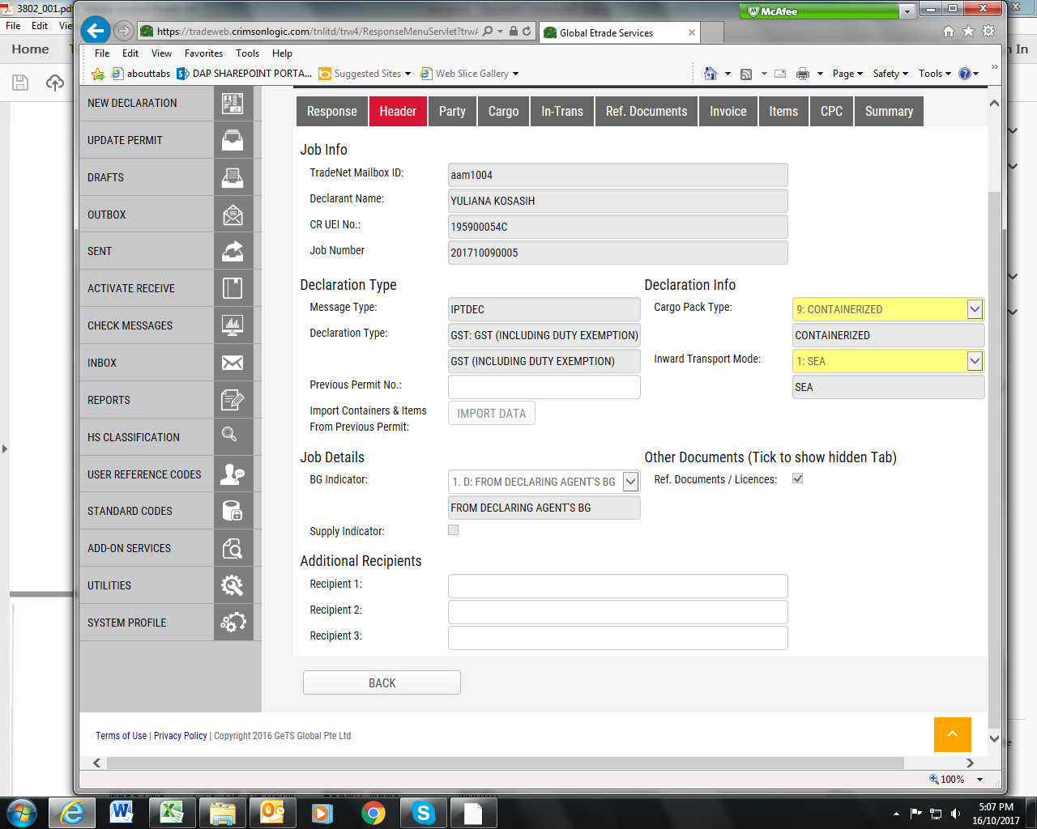

Fields to complete

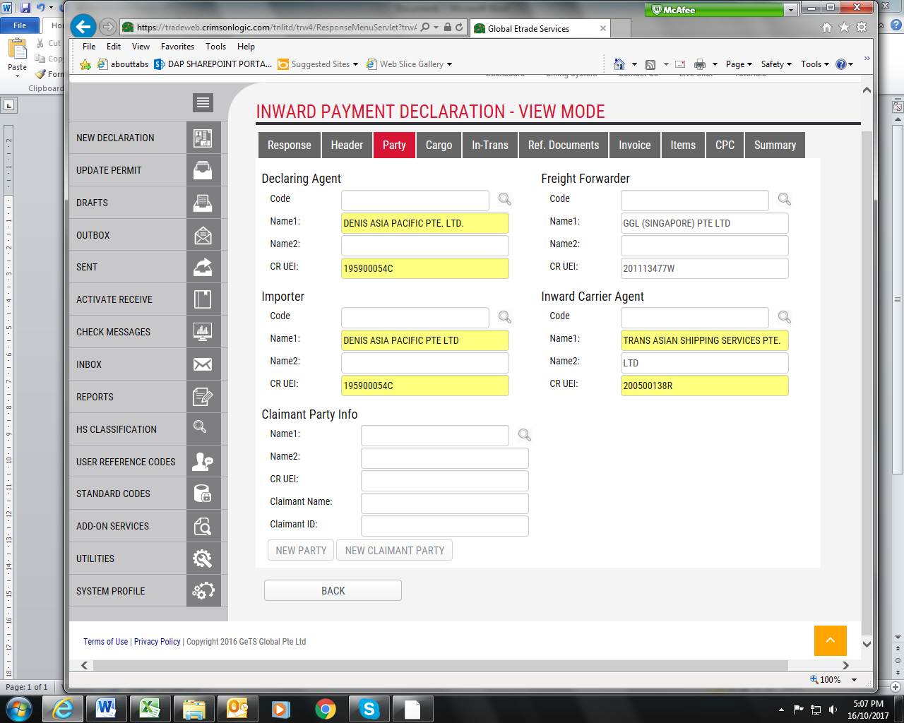

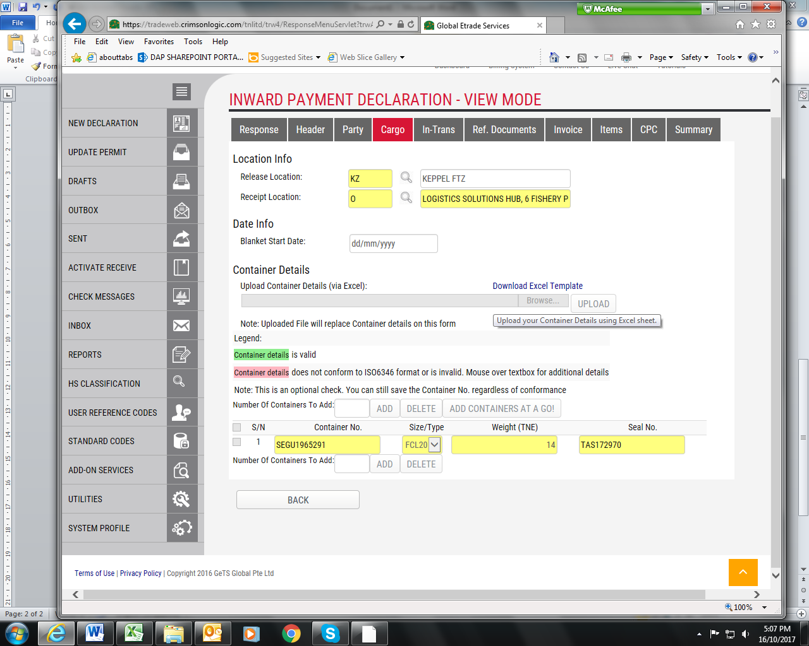

If there is more than 1 container.

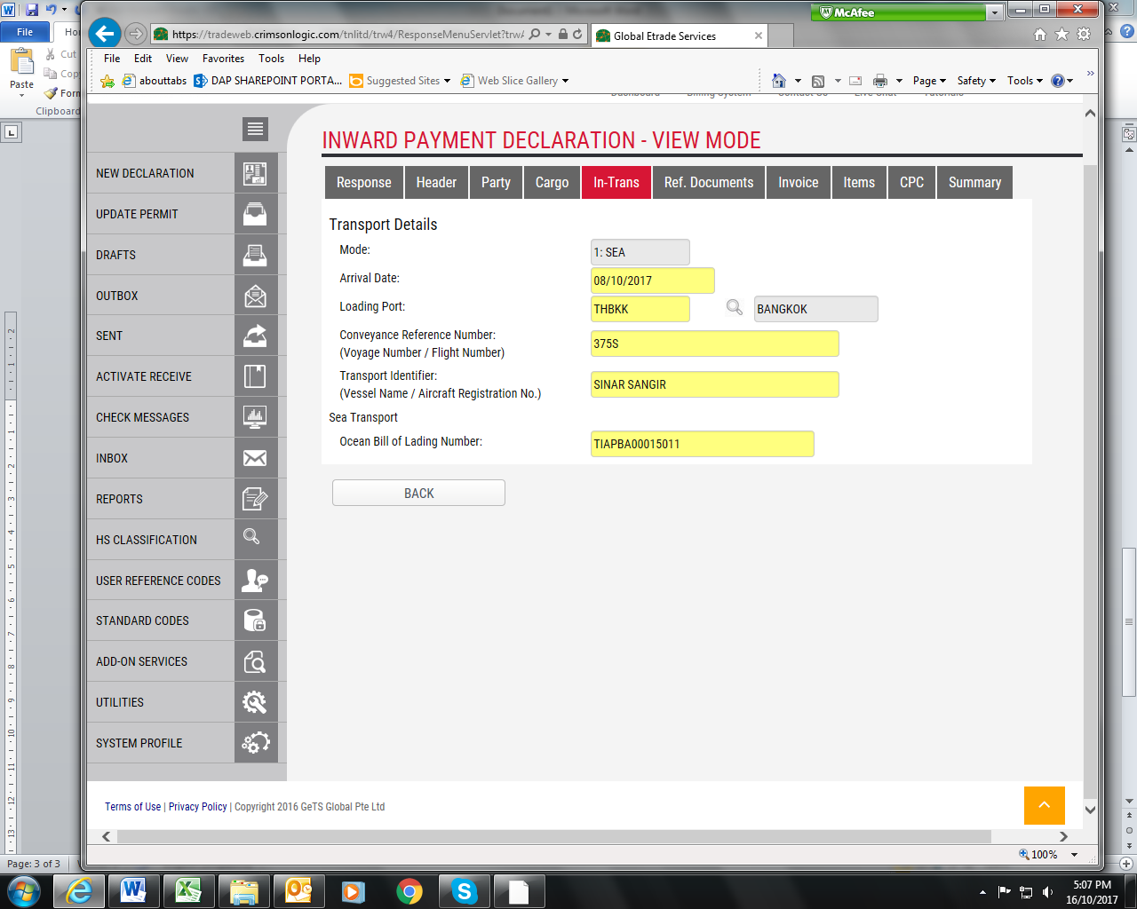

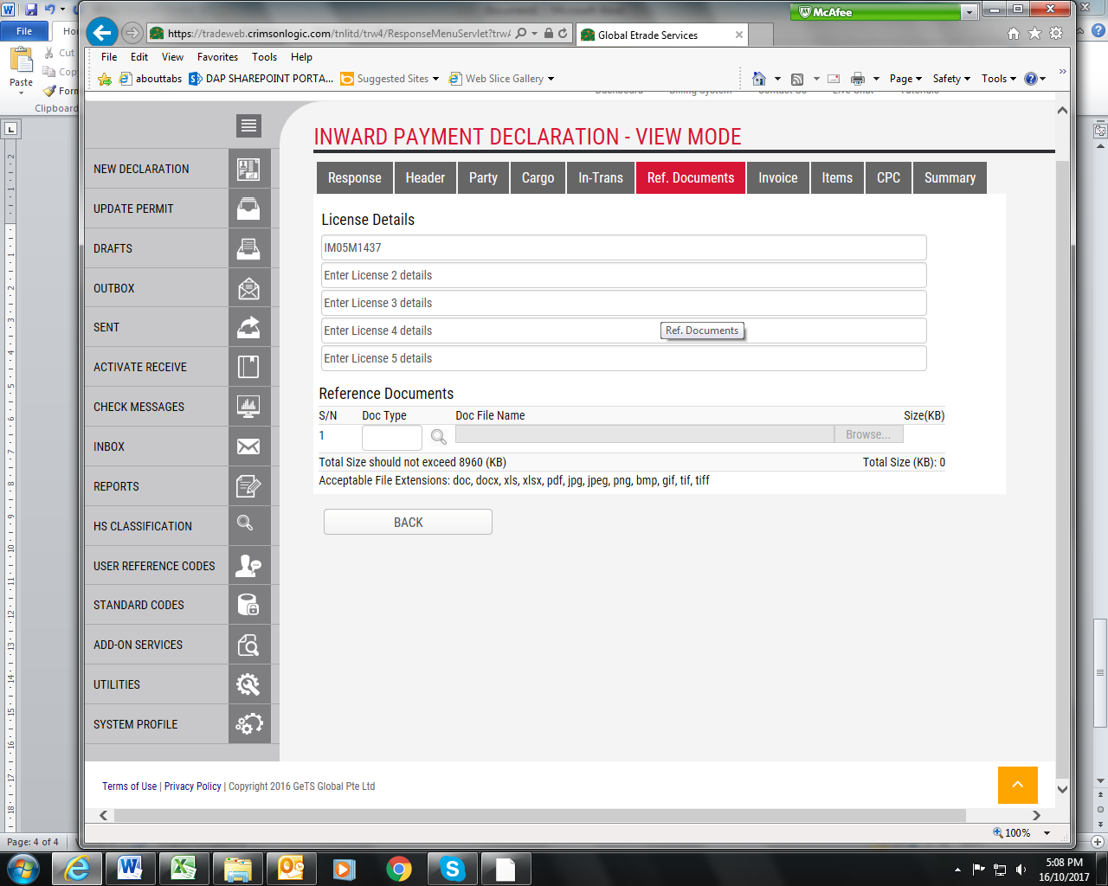

Licence details:

|  |  |
| --- | --- |
| DAP Food | IP03G0085 |
| DAP Fish | IM05M1437 |
| CT Food | IP03G0170 |
| CT Fish | IM05G0622 |

* PDF file attachment, if required.

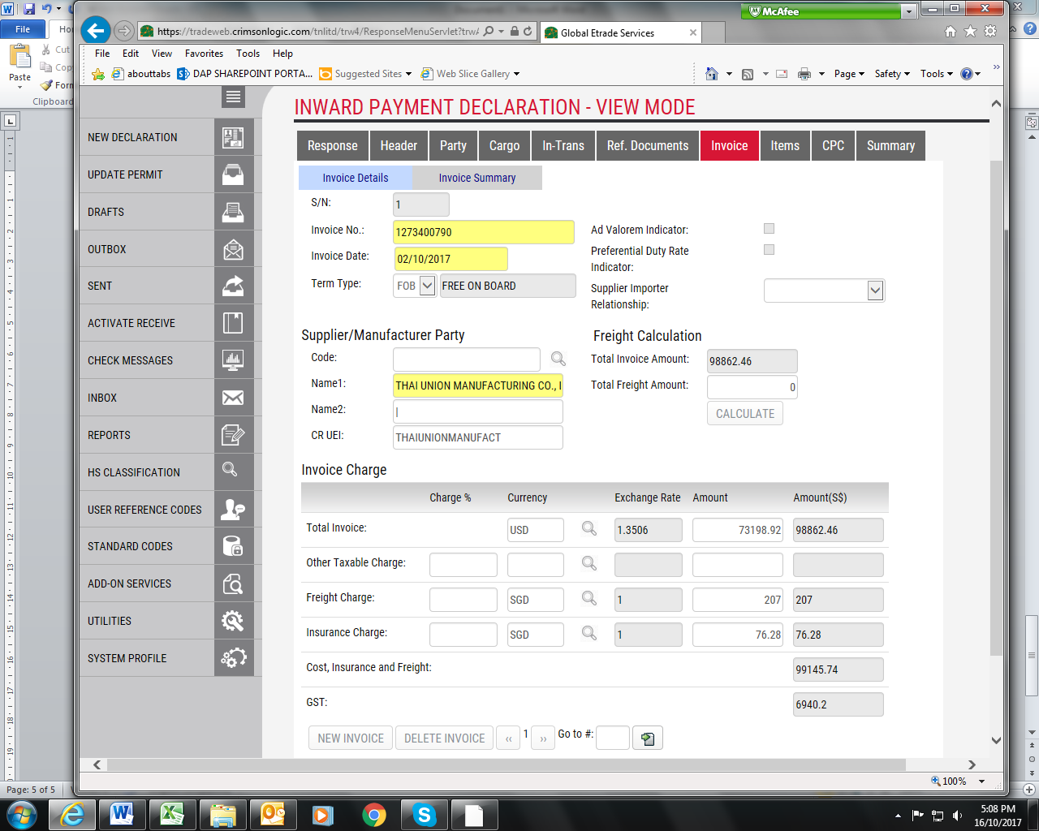

Term Type:

EXW /FAS /FOB /CNI/CFR/CIF

Invoice charge depending on Term Type:

EXW/FAS/FOB - will require to indicate Freight and insurance charges.

CNI – only Freight charge.

CFR – only insurance charge.

CIF – no need of Freight nor insurance charges.

**ITEMS HEADER – PART 1**

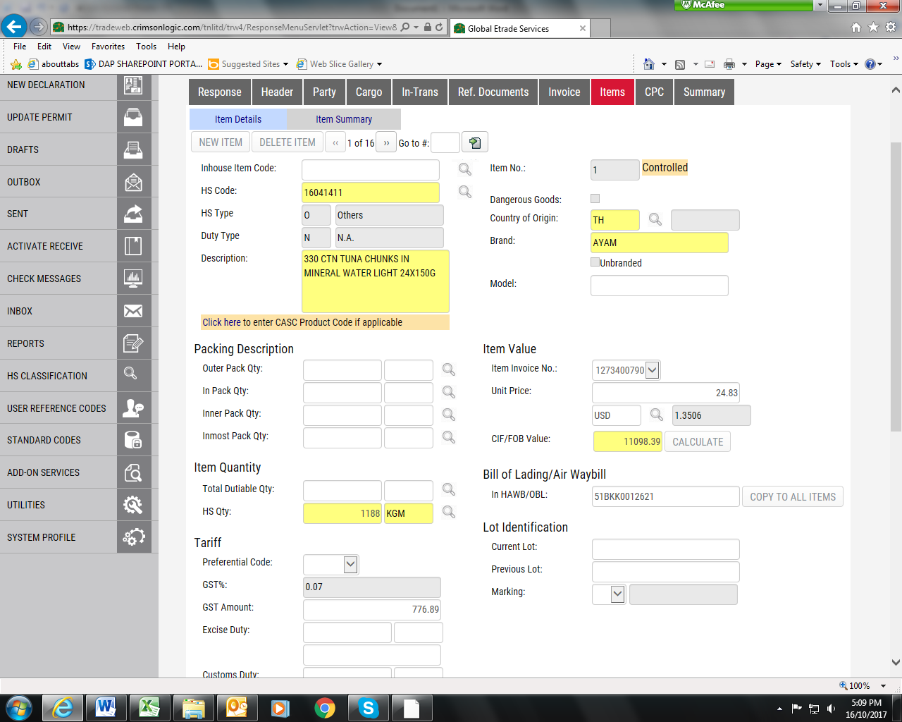

Quantity manually added into description. (default description without qty)

HS Qty: Quantity (No. of units) x item sku Net Weight (item master file)

**REFER TO PG 11 & 12! ITEMS HEADER PART 1a & 1b!**

**ITEMS HEADER – PART 2**

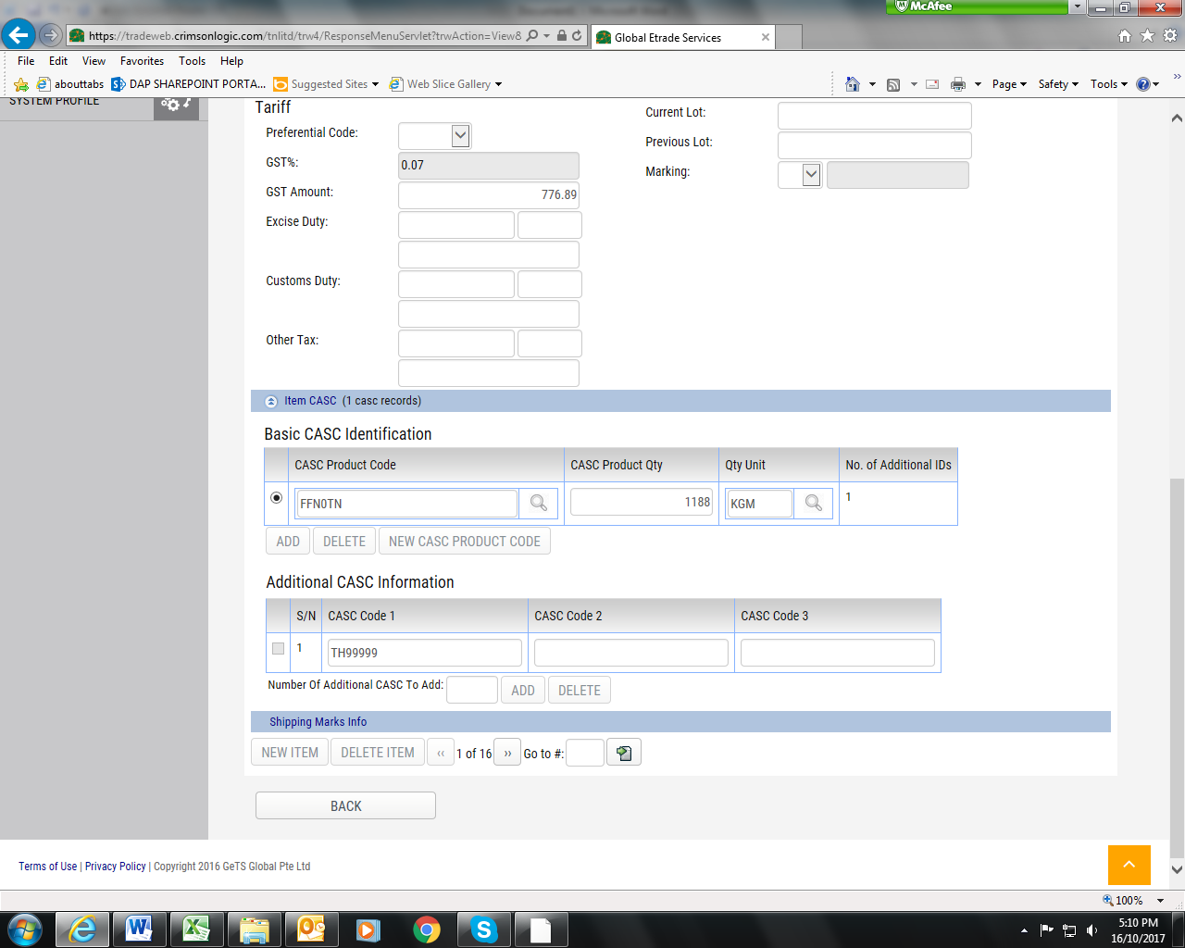

Same as **HS Qty**: Quantity (No. of units) x item sku Net Weight (item master file) [page 9]

Info from item master file.

**POP UP from ITEMS Header pg 9 [PAGE 11-part 1a & 12 –part 1b]**

**ITEMS HEADER PART 1a** 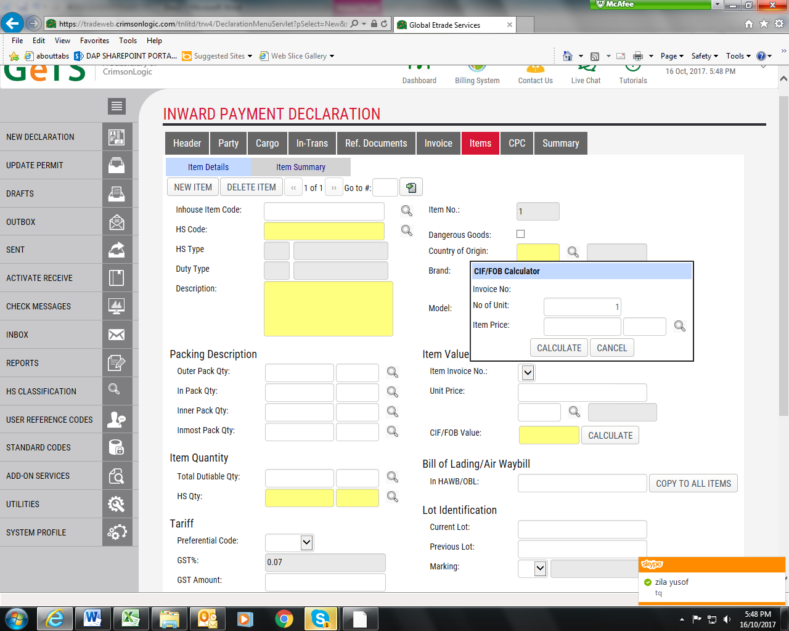

**POP UP from ITEMS Header pg 9 [PAGE 11-part 1a & 12 –part 1b]**

**ITEMS HEADER PART 1b**

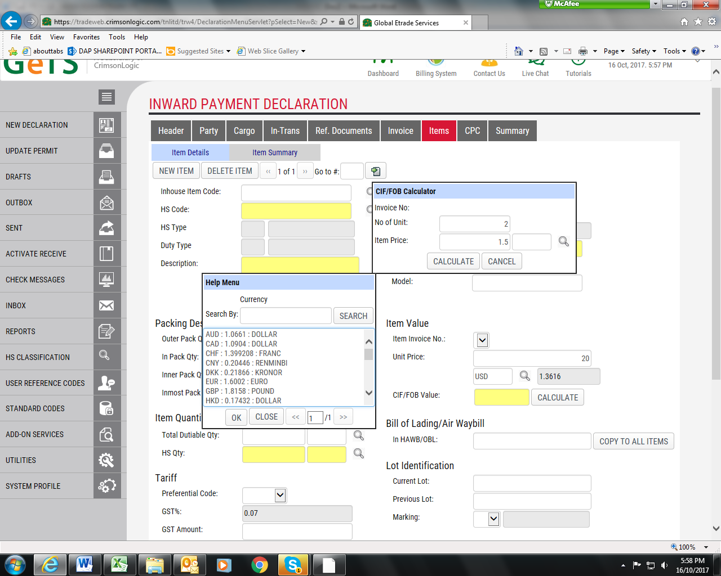

Currency - select

Ok

Calculate

Continuation from PG 10

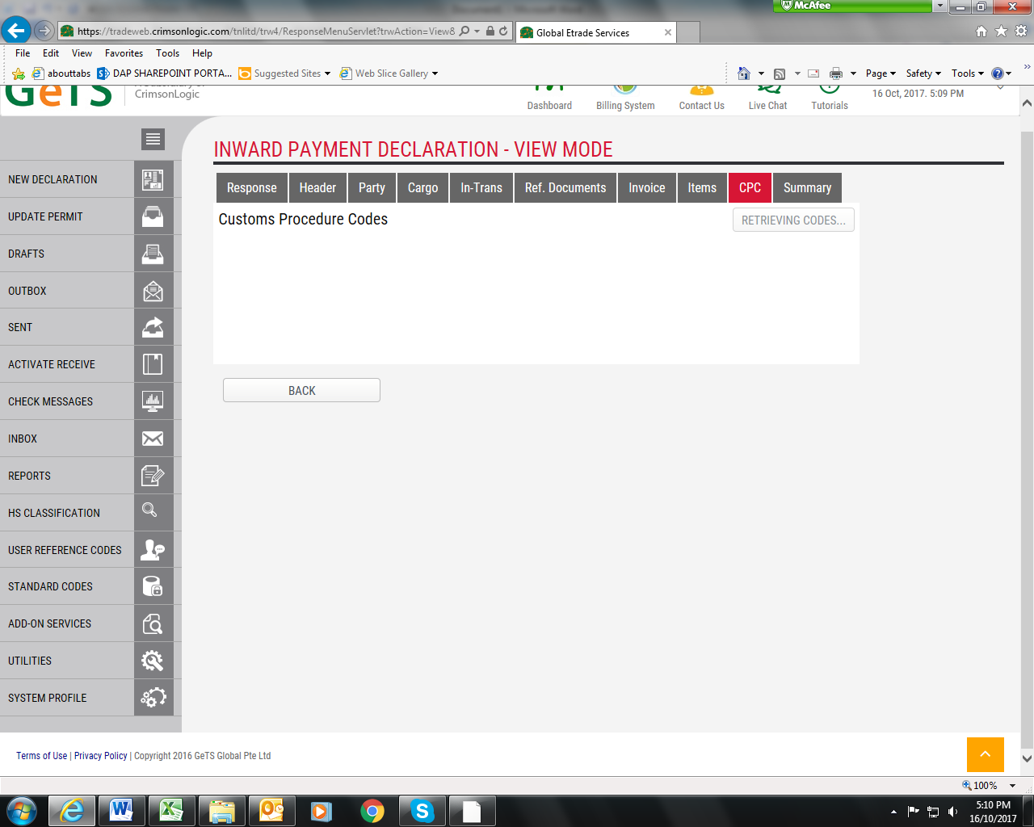

CPC header – NO FIELDS REQUIRED TO COMPLETE.

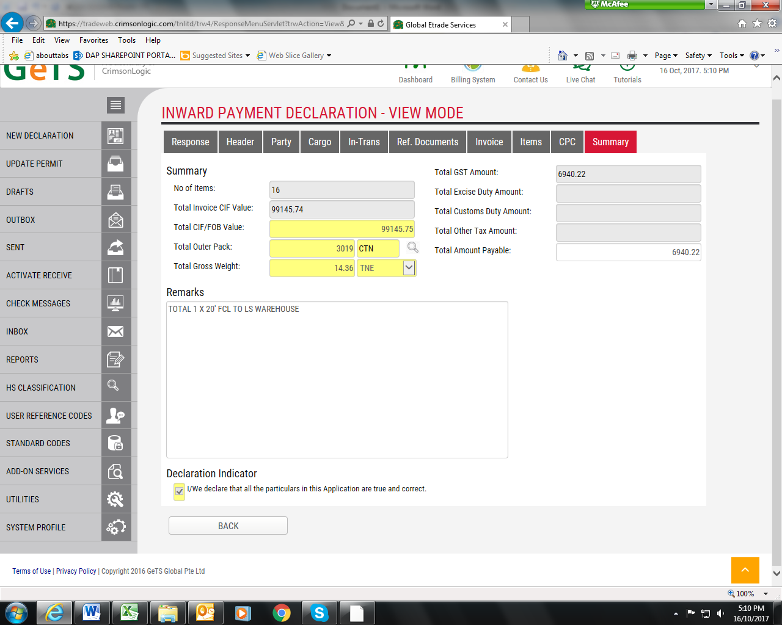

Please add from all line items quantities.

Gross Wt column in item master file. (summation of line items wt)

GER # - to indicate in Remarks column & free text field.

SAVE & SEND.